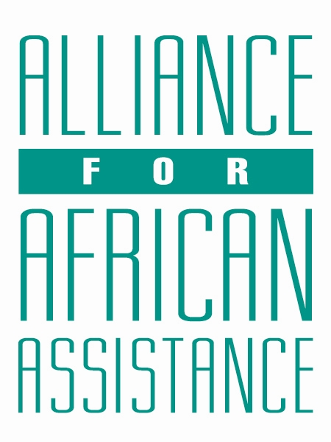
CSP Child Biography Form

PERSONAL INFORMATION
Child’s Village  (Where he/she currently lives) | Pupwonya South
Child’s District  (Where he/she currently lives) | Amuru
Child’s County  (Where he/she currently lives) | Kilak North
Child’s Christian Name | Tonny Blair
Child’s Acholi Name | Ogenrwot
Child’s Date of Birth | 25/12/2009
Child’s Gender | Male
Child’s Favorite Game/Activity | Football

FAMILY INFORMATION
Mother’s Name | Acayo Christine
Is mother alive? | Yes
Mother’s Profession, if living.  (If farming, which crops are presently being grown?) | Peasant farmer, cassava, maize and potatoes
Father’s Name | Masaba
Is father alive? | Deceased
Father’s Profession, if living.
(If farming, which crops are presently being grown?)
If both parents are living, please give the reason that this child is in need of sponsorship. Based upon the family’s current needs and situation, what kind of activities might enable the parents to become self- sufficient and able to pay the costs of educating their children?
If parents have passed away, please give the reason for their passing (so long as the family is comfortable sharing this information. If the family is not comfortable sharing, please state this) | The father was poisoned.
Guardian’s Name (If not parent(s)
Guardian’s relationship to the child (aunt, neighbor, grandfather, etc.)
Guardian’s Profession (If farming, which crops are presently being grown?)
Number of sisters with whom the child lives | 04
Number of brothers with whom the child lives | 03
Others with whom child lives | 03 cousins
Description of what the child helps with at home | Rearing animals(goats)
Additional Information

ACADEMIC INFORMATION
Is child currently attending school? | Yes
Name of School | Pupwonya primary school
Class Level | Primary Six
Favorite Subject | Mathematics
Future Dreams (Profession) | Doctor

