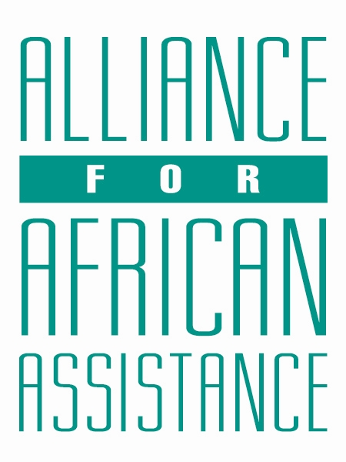
CSP Child Biography Form

PERSONAL INFORMATION
Child’s Village  (Where he/she currently lives) | BARDEGE-NEGRI
Child’s District  (Where he/she currently lives) | GULU
Child’s County  (Where he/she currently lives) | BARDEGE
Child’s Christian Name | DERRICK
Child’s Acholi Name | KOMAKECK
Child’s Date of Birth | 28/12/2004
Child’s Gender | MALE
Child’s Favorite Game/Activity | FOOTBALL

FAMILY INFORMATION
Mother’s Name | ANENA NANCY
Is mother alive? | ALIVE
Mother’s Profession, if living.  (If farming, which crops are presently being grown?) | PEASANT FARMER. PRESENTLY SHE HAS PLANTED CASSAVA
Father’s Name | OLOYA MARTIN
Is father alive? | DECEASED
Father’s Profession, if living.
(If farming, which crops are presently being grown?)
If both parents are living, please give the reason that this child is in need of sponsorship. Based upon the family’s current needs and situation, what kind of activities might enable the parents to become self- sufficient and able to pay the costs of educating their children?
If parents have passed away, please give the reason for their passing (so long as the family is comfortable sharing this information. If the family is not comfortable sharing, please state this)
Guardian’s Name (If not parent(s)
Guardian’s relationship to the child (aunt, neighbor, grandfather, etc.)
Guardian’s Profession (If farming, which crops are presently being grown?)
Number of sisters with whom the child lives | 02
Number of brothers with whom the child lives | 05
Others with whom child lives | 2 COUSINS
Description of what the child helps with at home | COOKING, FETCHING FIREWOOD AND LAYING BRICKS
Additional Information

ACADEMIC INFORMATION
Is child currently attending school? | YES
Name of School | GULU CITY HIGH SCHOOL
Class Level | S.1
Favorite Subject | HISTORY
Future Dreams (Profession) | TEACHER

