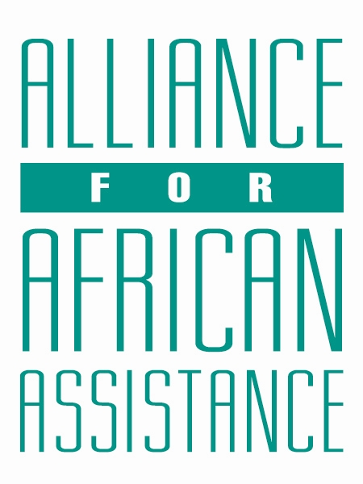
CSP Child Biography Form

PERSONAL INFORMATION
Child’s Village  (Where he/she currently lives) | ANGAGURA
Child’s District  (Where he/she currently lives) | PADER
Child’s County  (Where he/she currently lives) | KIBEGA
Child’s Christian Name | EMMANUEL
Child’s Acholi Name | MEGOLONYO
Child’s Date of Birth | 25/02/2010
Child’s Gender | MALE
Child’s Favorite Game/Activity | FOOTBALL

FAMILY INFORMATION
Mother’s Name | ARACH SUSAN HARRIET
Is mother alive? | YES
Mother’s Profession, if living.  (If farming, which crops are presently being grown?) | PEASANT FARMER [ SIMSIM AND SORGUM]
Father’s Name | OKWERA CHARLES
Is father alive? | DECEASED
Father’s Profession, if living.
(If farming, which crops are presently being grown?)
If both parents are living, please give the reason that this child is in need of sponsorship. Based upon the family’s current needs and situation, what kind of activities might enable the parents to become self- sufficient and able to pay the costs of educating their children?
If parents have passed away, please give the reason for their passing (so long as the family is comfortable sharing this information. If the family is not comfortable sharing, please state this) | DIED OF ACCIDENT
Guardian’s Name (If not parent(s)
Guardian’s relationship to the child (aunt, neighbor, grandfather, etc.)
Guardian’s Profession (If farming, which crops are presently being grown?)
Number of sisters with whom the child lives | 03
Number of brothers with whom the child lives | 01
Others with whom child lives | 01 [COUSIN]
Description of what the child helps with at home | SWEEPING COMPOUND, FETCHING WATER AND GARDEN WORK
Additional Information

ACADEMIC INFORMATION
Is child currently attending school? | YES
Name of School | LAYIBI HIGH SCHOOL
Class Level | SENIOR ONE
Favorite Subject | BIOLOGY
Future Dreams (Profession) | DOCTOR

