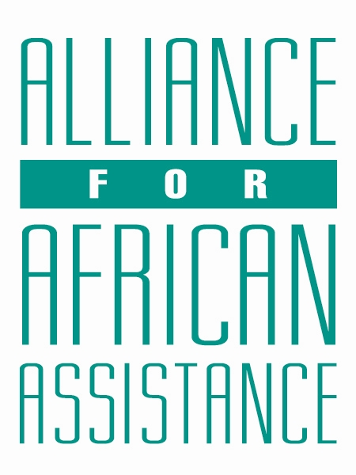
CSP Child Biography Form

PERSONAL INFORMATION
Child’s Village  (Where he/she currently lives) | AGORO VILLAGE
Child’s District  (Where he/she currently lives) | AMURU
Child’s County  (Where he/she currently lives) | KILAK NORTH
Child’s Christian Name | INNOCENT
Child’s Acholi Name | OBEDI CANDANO
Child’s Date of Birth | 11/12/2002
Child’s Gender | MALE
Child’s Favorite Game/Activity | MUSIC DANCE AND DRAMA (MDD)

FAMILY INFORMATION
Mother’s Name | APIYO CONCY
Is mother alive? | YES
Mother’s Profession, if living.  (If farming, which crops are presently being grown?) | PEASANT FARMER
Father’s Name | OKEMA VINCENT
Is father alive? | DECEASED
Father’s Profession, if living.
(If farming, which crops are presently being grown?)
If both parents are living, please give the reason that this child is in need of sponsorship. Based upon the family’s current needs and situation, what kind of activities might enable the parents to become self- sufficient and able to pay the costs of educating their children?
If parents have passed away, please give the reason for their passing (so long as the family is comfortable sharing this information. If the family is not comfortable sharing, please state this)
Guardian’s Name (If not parent(s)
Guardian’s relationship to the child (aunt, neighbor, grandfather, etc.)
Guardian’s Profession (If farming, which crops are presently being grown?)
Number of sisters with whom the child lives | 02
Number of brothers with whom the child lives | 06
Others with whom child lives | NIL
Description of what the child helps with at home | DIGGING
Additional Information

ACADEMIC INFORMATION
Is child currently attending school? | YES
Name of School | ST ANDREW MOLLY FOUNDATION NURSERY AND PRIMARY SCHOOL
Class Level | COMPLETED PRIMARY SEVEN LAST YEAR, BUT THE FAMILY CAN NOLONGER SUPPORT HIS EDUCATION.
Favorite Subject | MATHEMATICS
Future Dreams (Profession) | PILOT

